Individual Logbook

Week 11
Dave Sushames
2026
Contents
Table 1
Discussion 1

Table
Category | Hours Completed
Team meetings | 6h 30m
Client meetings
Advisor meetings | 3h 30m
Research | 2h 50m
Development | 12h 15m
Testing
Documentation | 11h 30m
Logbook preparation | 1
Other
Total hours for this week | 37h 35m
Running total of hours completed for Capstone | 258h 25m

Logbook content notes
Team meetings:
Monday 1-2:30pm Catching up on what everyone has been doing, assigning tasks for this week.
Tuesday 10-12pm: Discussed work to be done, audited weekly logs.
Thursday 1-3pm: Assigning tasks: Matt demonstrating JSON and CSV files as different methods of LLM integration. Olivia is doing the Review. I’m doing the Poster.
Friday 10:30-11:30: Debrief after Bryce’s meeting, discussing how to work on the scripts.
Advisor meetings:
Tuesday 9-10: Bryce meeting, discussed accessing Bryce’s network for Nmap scanning. Deciding a good program to make the poster in, as Publisher is discontinued in October.

Friday 8-10:30 Bryce meeting. Discussed Matt’s scripts, standardising files, and converting the AI reports into a more readable format.
Research
See research log
Development
Mon 8:30 – 11:30 Editing Matt’s Ninemost script to prevent the end of line cut-offs and ANSI characters from appearing. 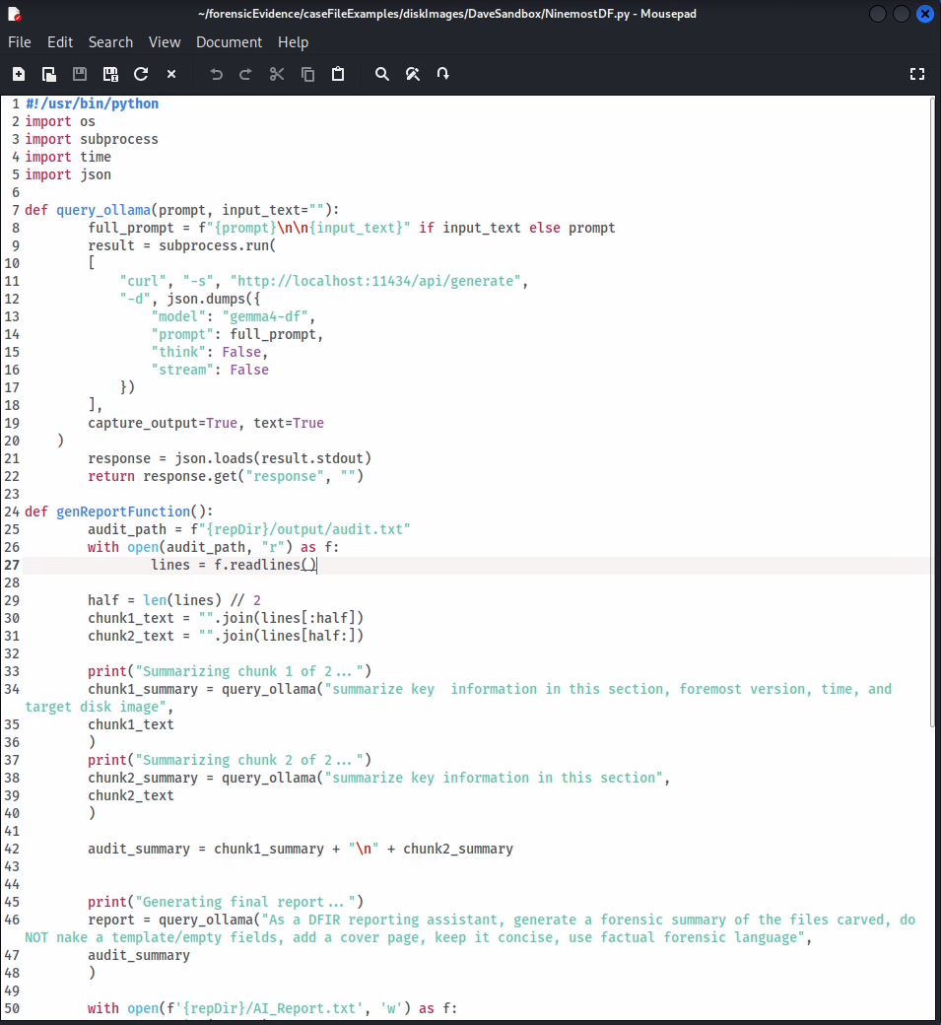
Previously the AI reports would appear as follows: 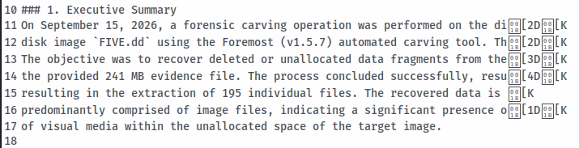The issue was it was doing it all in a shell terminal , which has inbuilt line wrapping and wants to keep the newline ANSI characters as text. I got it to start using curl and an ollama API instead, so it prints cleanly. 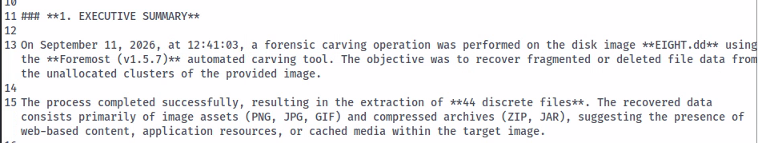
NinemostDF.py
Monday 12-1pm: Working on making the same changes to the Nmap script.
Monday 2:30-3:45pm Finishing changes to the Nmap script, adding the token tracking to the Foremost script.
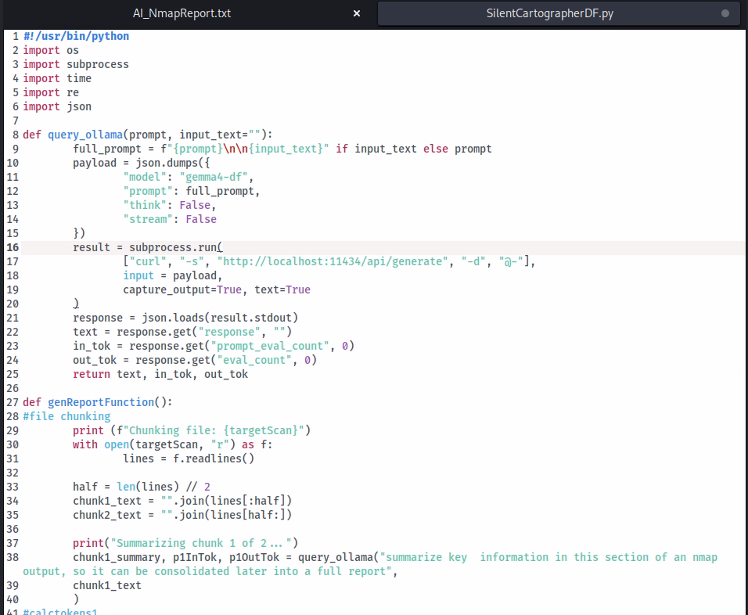
Tuesday 12:30-4:30: Started working on a foremost report for the file EIGHT.dd. Need to do nine human reports across the team.
Wednesday 8:30-11:30: Figuring out the documentation for file handling, as well as how to use chmod. Started work on a report for TWO.dd, before being told that we are only doing three reports per tool, so nine *total*. As Olivia and Sam have done reports on THREE.dd and NINE.dd respectively already, a report on TWO.dd is unnecessary.
Testing
Documentation
Wednesday 12-4pm Working on the new Gantt chart for the Self Management Review with Olivia. 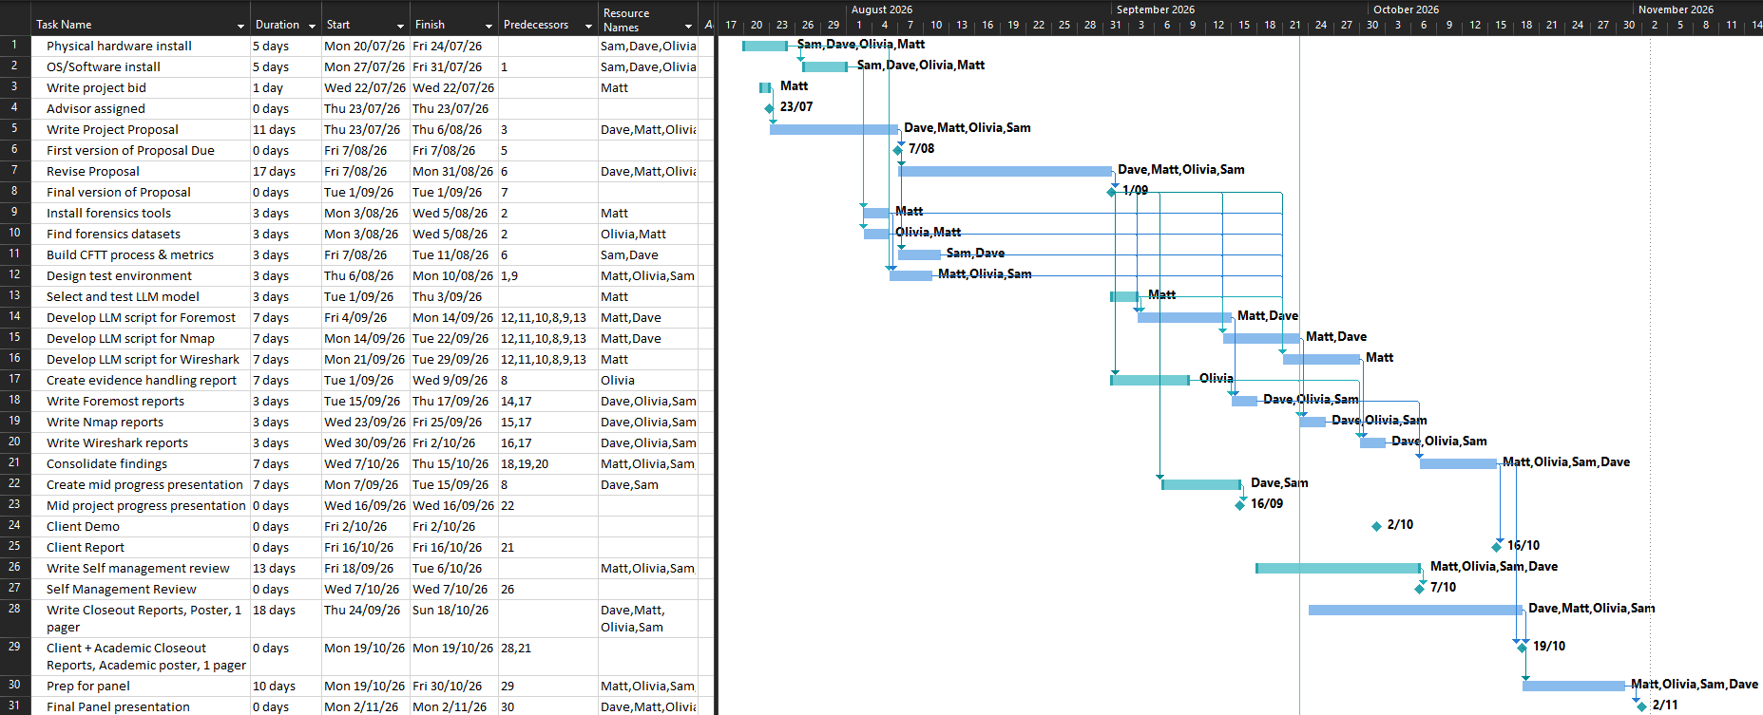
Thursday 10:30-12:30pm: Started work on the layout of the academic poster.
Thursday 3-4:30pm: Continued working on the academic poster. 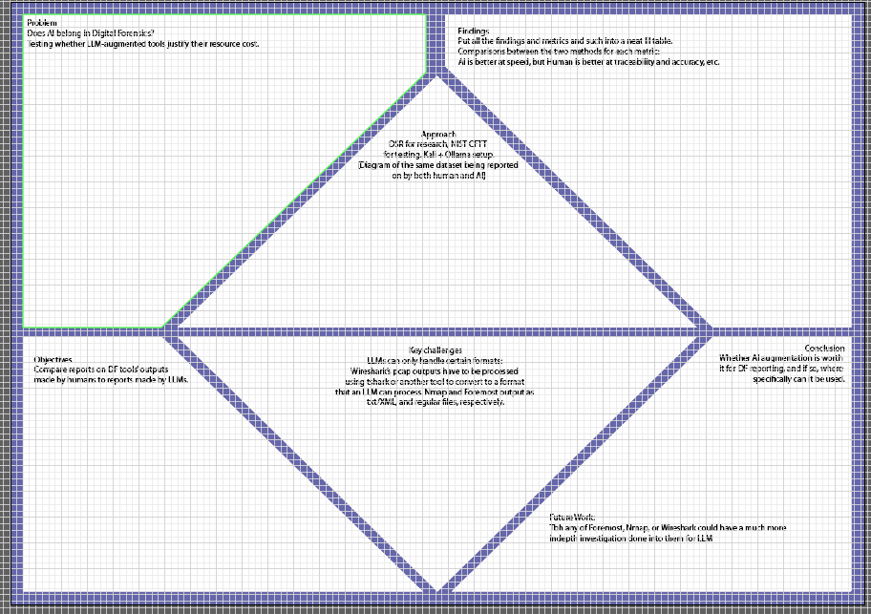
Friday 12-4pm: Adjusting the poster panel layout, team said we should stick to a simple 3 panel layout for now. We can try a fancier design once we have some more content on the poster. Adding more content.
